**Scalar and vector fields**

1. **Gradient**



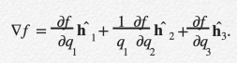

**Explain (in words and/or a diagram) why the “q2” axis now has a 1/q1 scaling factor?**

the incremental distances for sides of an infinitesimal patch in the z=constant place have lengths dr and rdq so need to divide q2 coord axis by r=q1 to normalize.

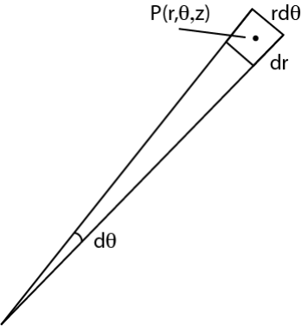

1. **Divergence**

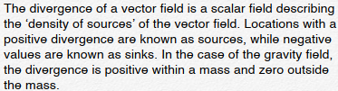

1. **curl**

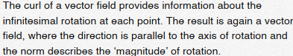

1. **div (curl v) = 0**

curl produces vector output that measures “vorticity” at a point with rotation axis oriented along each coordinate axis, so result is perpendicular to coordinate axis. div measures change in vector components along their own coordinate axes: no component exists after curl operation.

1. **Curl (grad f) = 0**

the curl of the gradient is zero means the rotation of the maximum variation of the f change at any point in space is zero.

1. **Laplacian operator**



Measures the amount to which the specific value of the scalar field at P differs from the predicted value based on surrounding points, i.e., measures the local smoothness (and thus predictability) of the field.



Harmonic field. Solutions (harmonic functions) to the field for one surface – outside of the source region- are solutions to the field everywhere else (outside the source region).

**Integral theorems**

1. **Gauss integral theorem**

allows the conversion of a volume integral into a surface integral, i.e. the reduction of dimension.

1. **Stokes**

Reduces volume integral to surface integral so can deduce properties (e.g. mean density distribution) throughout a volume from measurements at the surface.

Stokes theorem uses the concept of an orientable surface. A surface is called orientable, if it is impossible to move from one side to the other side of the surface without crossing its boundary.

**ODE**

1. **Homogeneous linear ODE with constant coefficients**

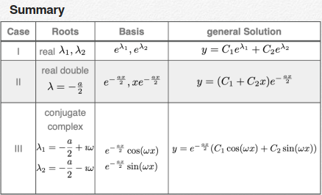

1. **Euler differential equation**

 

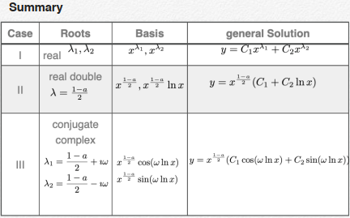

1. **Existence Uniqueness Wronskian**



1. **Nonhomogeneous linear ODE**

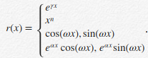

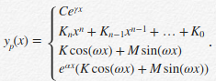

Method of the variation of the parameters











1. **Bernoulli**





1. **Power series method**





**Laplace Equation**

1. **Potential theory**



**The integral theorem of Gauss:**

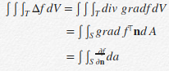



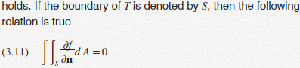

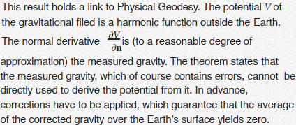

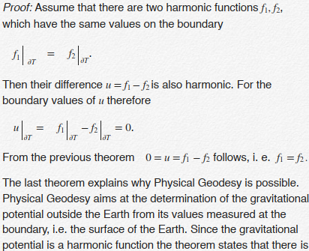



1. **Harmonic functions outside a sphere**



**Laplace operator:**





**General solution:**



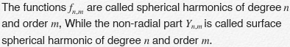

**Taylor series**

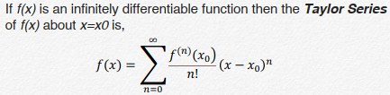

**Partial Differential Equations**



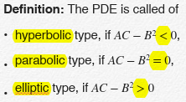





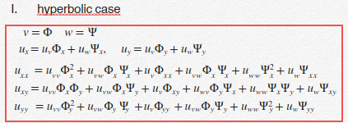



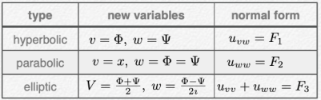

1. **Wave equation**

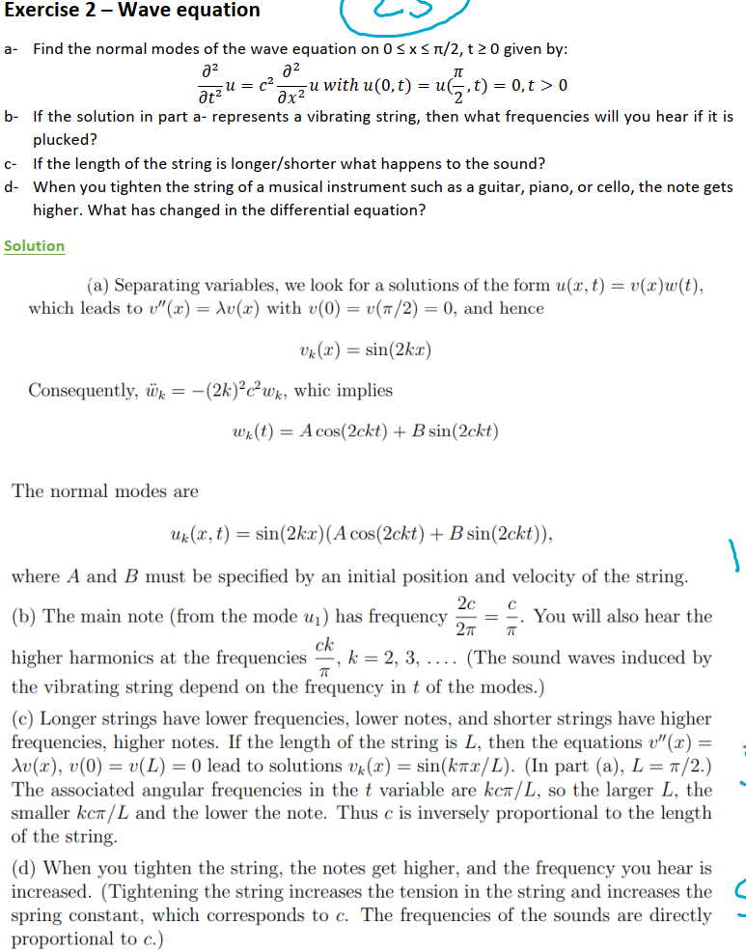



**Exploring data**

1. **Scatter plot**

If practical, consider plotting every individual data value on a single graph. Such “scatter” plots show graphically the correlation between points, the orientation of the data, bad outliers, and the spread of clusters. It is just a visual appearance of a trend.

1. **Schematic plots**

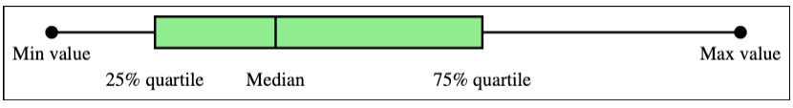**“box-and-whisker”**

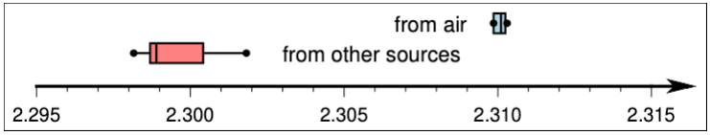

which highlights the different ranges of the data groupings.

1. **Histograms**

Histograms convey an accurate impression of the data distribution even if it is multimodal.

1. **Smoothing**

The purpose of smoothing is to highlight the general trend of the data and suppress high-frequency oscillations. The **median filter** is typically a three-point filter. This technique is very efficient at removing isolated spikes or outliers in the data since the bad points will be completely ignored as they will never occupy the median position, unless they appear in groups of two or more.

1. **Error analysis**

uncertainty in a function

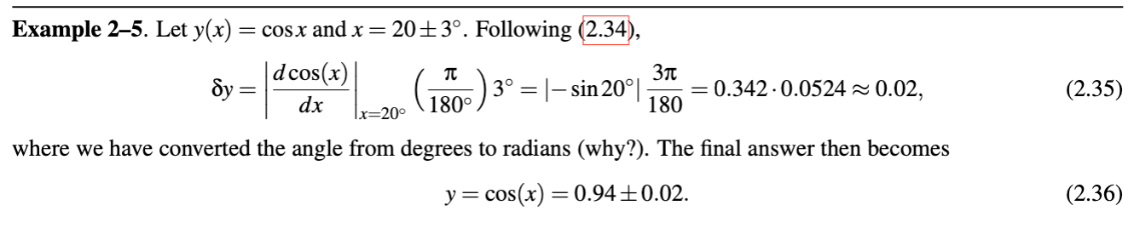

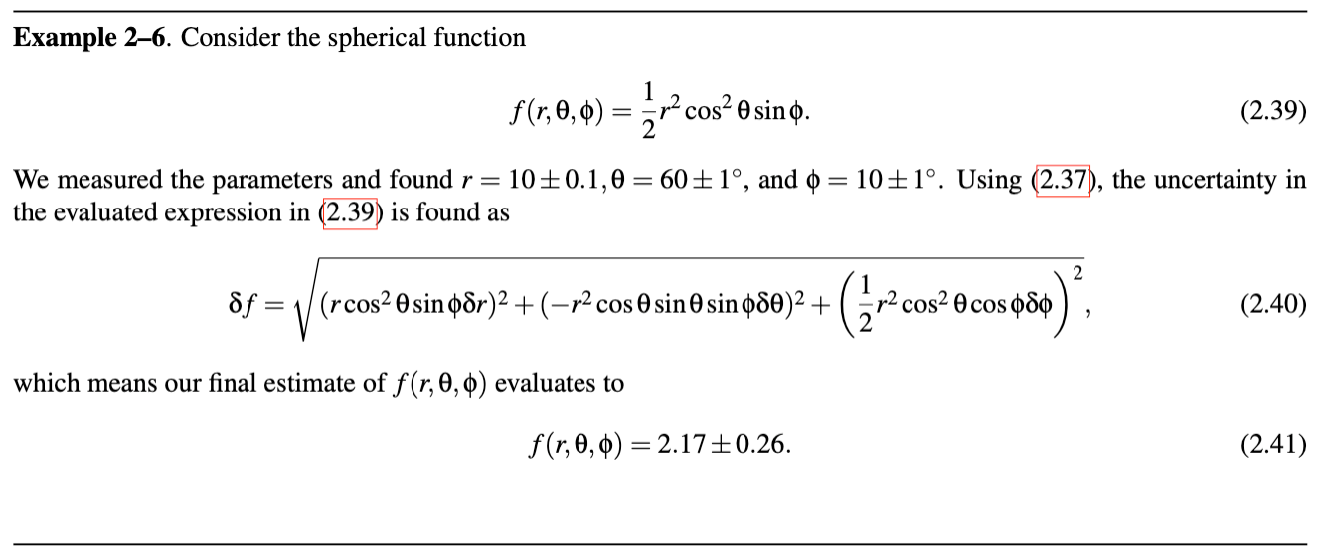

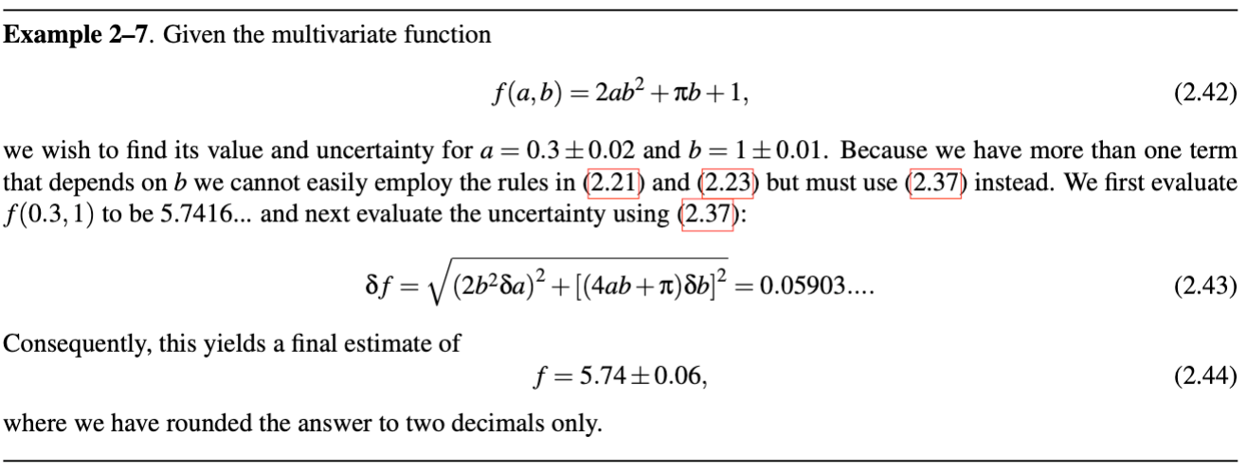

**Statistical concepts**

1. **law of large numbers**

If a situation, trial, or experiment is repeated again and again, the proportion of successes will tend to approach the probability that any one outcome will be a success.

1. **Mutually exclusive**

Two events that have no elements in common, meaning they cannot both occur at the same time.

1. **Bayes basic theorem**

implies that the probability of both events A and B occurring is given by the probability of one event occurring multiplied by the probability that the other event will occur given that the ﬁrst one already has occurred (occurs or will occur).



1. **Bayes general theorem**

If there are more than one event Bi (all mutually exclusive) that are conditionally related to an event A, then P(A) is simply the sum of the conditional probabilities of the events Bi times their individual probabilities, i.e.



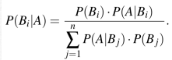

1. **Sample standard deviation**



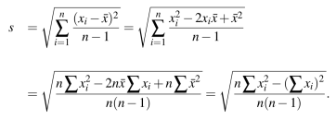

Note that we are dividing by n − 1 rather than by n. This is done because x ̄ must ﬁrst be estimated from the sample rather than being a given parameter of the population, such as μ and N.

1. **Central limit theorem**

If n (the sample size) is large, the theoretical sampling distribution of the mean can be approximated closely with a normal distribution.



1. **Pearson correlation coefficient**



If |r| is close to 1, then the variables are strongly correlated or anti-correlated. Values of r close to 0 mean that there is little signiﬁcant correlation between the data pairs.

Note in particular example (f), which presents data that are clearly correlated (i.e., all pairs lie on a circle), yet r = 0. This occurs because r is a measure of a linear relationship between values; a nonlinear relationship may not register a signiﬁcant correlation.

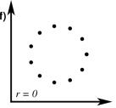

1. **Binomial probability distribution**



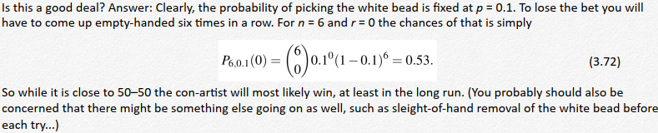

1. **Poisson distribution**

The Poisson distribution can be used to evaluate the probabilities for the occurrence of

rare events such as large earthquakes, volcanic eruptions, and reversals of the geomagnetic ﬁeld.

One such case arises when the probability p for one event is very small and n is large. Such events are called rare, and the discrete distribution may then be approximated by

where λ = np is the rate of occurrence.

1. **Normal distribution**



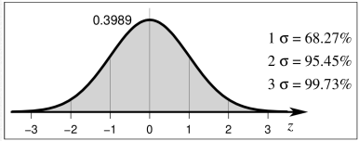

1. **Approximate binomial distribution**



1. **The exponential distribution**

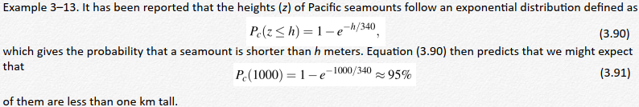

1. **Log-normal distribution**

Taking the logarithm of your data may make the transformed distribution look normal. If this is the case, you can apply standard statistical techniques applicable to normal distributions to the logarithm of your data and convert the results (e.g., mean, standard deviation) back to get the proper units.

1. **Inferences about means**

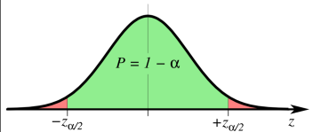

The normal score for our sample mean is

Since this statistic is normally distributed, we know that the probability is 1 − α that z will take on a value in the interval −zα/2 < z < +zα/2. Plugging in for the limits on z,



1. **Small samples**

For smaller samples we must assume instead that the population we are sampling is normally distributed. whose distribution is called the Student’s t-distribution (Figure 3.17). It is similar to the normal distribution, but its shape depends on the degrees of freedom, ν = n − 1.



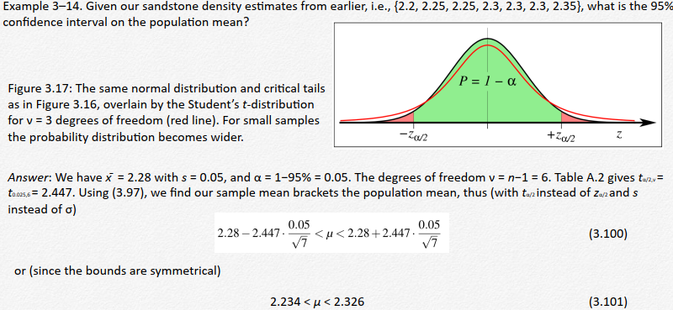

1. **The Null Hypothesis**

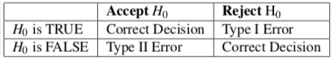

We saw in our example that the type II error probability depended on the value of μ. Since μ is typically not known, it is common to simply either reject H0 or reserve judgment (i.e., never accept H0). This way we avoid committing a type II error altogether, at the expense of never accepting H0. We call this a signiﬁcance test and say that the results are statistically signiﬁcant if we can reject H0. If not, the results are not statistically signiﬁcant, and we attempt no further decisions. Of course, we may be wrong in rejecting H0 but we can always state the likelihood of being wrong as α. Hence, in statistics we can only disprove hypotheses, but never prove them.

1. **Degree of freedom**

Once we use the mean in subsequent calculations, we must reduce ν by one, since any individual data point can now be obtained from that mean and any n − 1 data points. In general, we say we lose one degree of freedom for each parameter we have estimated from the data.

1. **Differences between sample means (equal variance)**

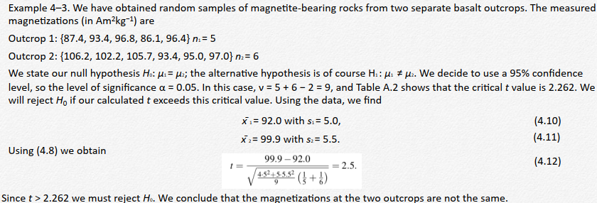

1. **Chi-square**

The most popular way of estimating σ is to compute the sample standard deviation. When investigating properties of σ via s we will be using the “chi-square” statistic, given by

1. **Comparing standard deviations from two samples**

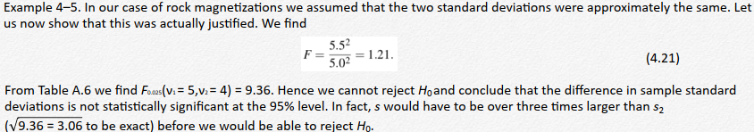

1. **Nonparametric Tests**

1. You have a small sample (n < 30) and you cannot assume that the population it came from is normal.

2. You have ordinal data (which can be ranked, but not operated on numerically).

In those cases, we must consider nonparametric methods, which make no assumptions about the shape of the data distribution. In particular, nonparametric tests do not involve the calculation of distribution parameters, such as the mean and standard deviation.

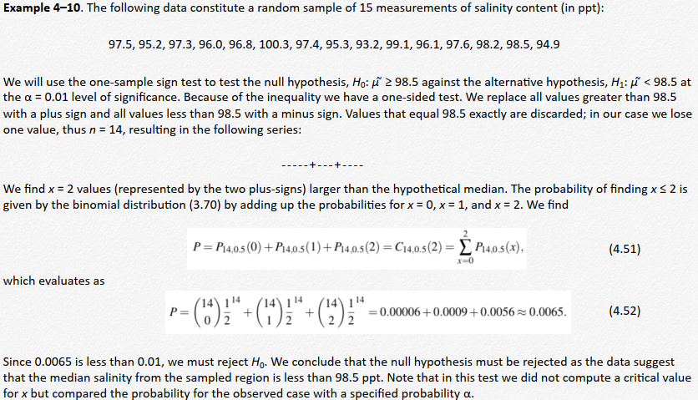

1. **Summary**

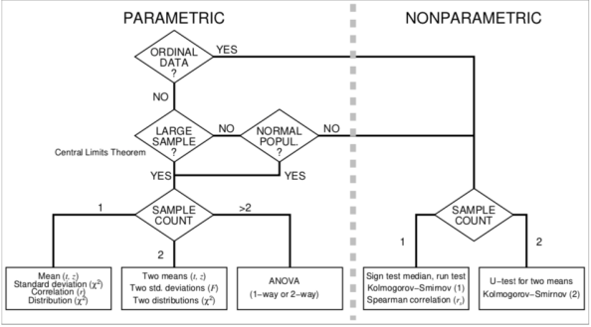

**Linear (matrix) algebra**

The method of least squares produces a ﬁt of a speciﬁed (usually continuous) basis to a set of data points which minimizes the sum of the squared misﬁt (error) between the ﬁtted curve and the data.

1. **Orthogonal regression**

Orthogonal regression is the correct way to determine linear relationships between x and y.

**Major axis:** 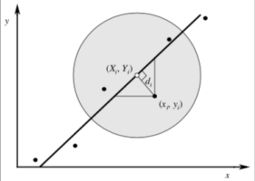

**Lagrange’s multipliers**: This method says we should form a new function F by adding the original function and all the constraints, with each constraint scaled by an unknown (Lagrange) multiplier λi. Since is actually n constraints, we ﬁnd:

 



**Reduced major axis (RMA) regression:** 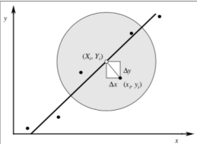

RMA regression minimizes the sum of the areas of the (white) rectangles deﬁned by the data points (black circles).

1. **The periodogram**

The periodogram is constructed by plotting 𝐴!" versus j, fj, ωj, or Pj. While often called the power spectrum, it is strictly speaking a raw, discrete periodogram.

1. **Aliasing of higher frequencies**

Higher frequencies, whose wavelengths are less than twice the spacing between sample points cannot be detected. Aliasing means that some frequencies will leak power into other frequencies.

1. **Convolution**

Convolution represents one of the most fundamental operations of time series analysis and is one of the most physically meaningful. For instance, it may

1. Amplify, attenuate, or delay the signal.

2. Modify or eliminate specific frequency components.

Because convolution is a slow calculation it is often advantageous to transform our data from one domain to the other, perform the simpler multiplication, and transform the data back to the original domain. The availability of fast Fourier transforms (FFTs) makes this approach practical.

1. **Filtering**

Filtering of data is typically performed in order to either smooth the signal or suppress power at particular frequencies or wavenumbers. So far, we have learned that ﬁltering can be considered an example of a convolution between the data and the ﬁlter.